**5.4 Logical DFD AS-IS System**

* **Context Diagram:**

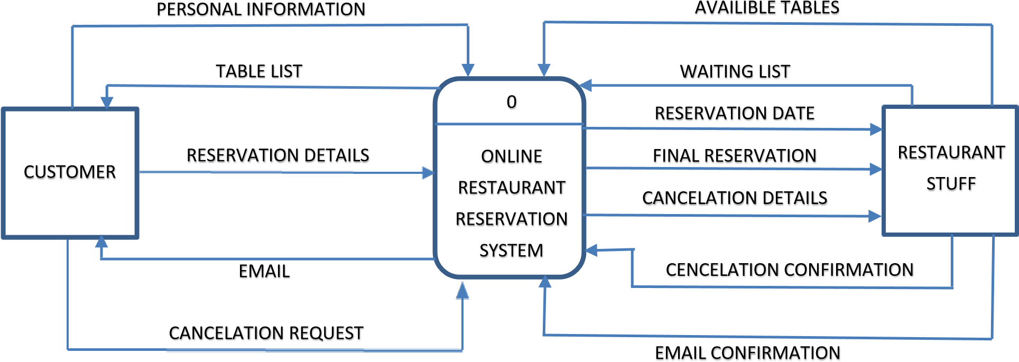

* **Diagram 0:**

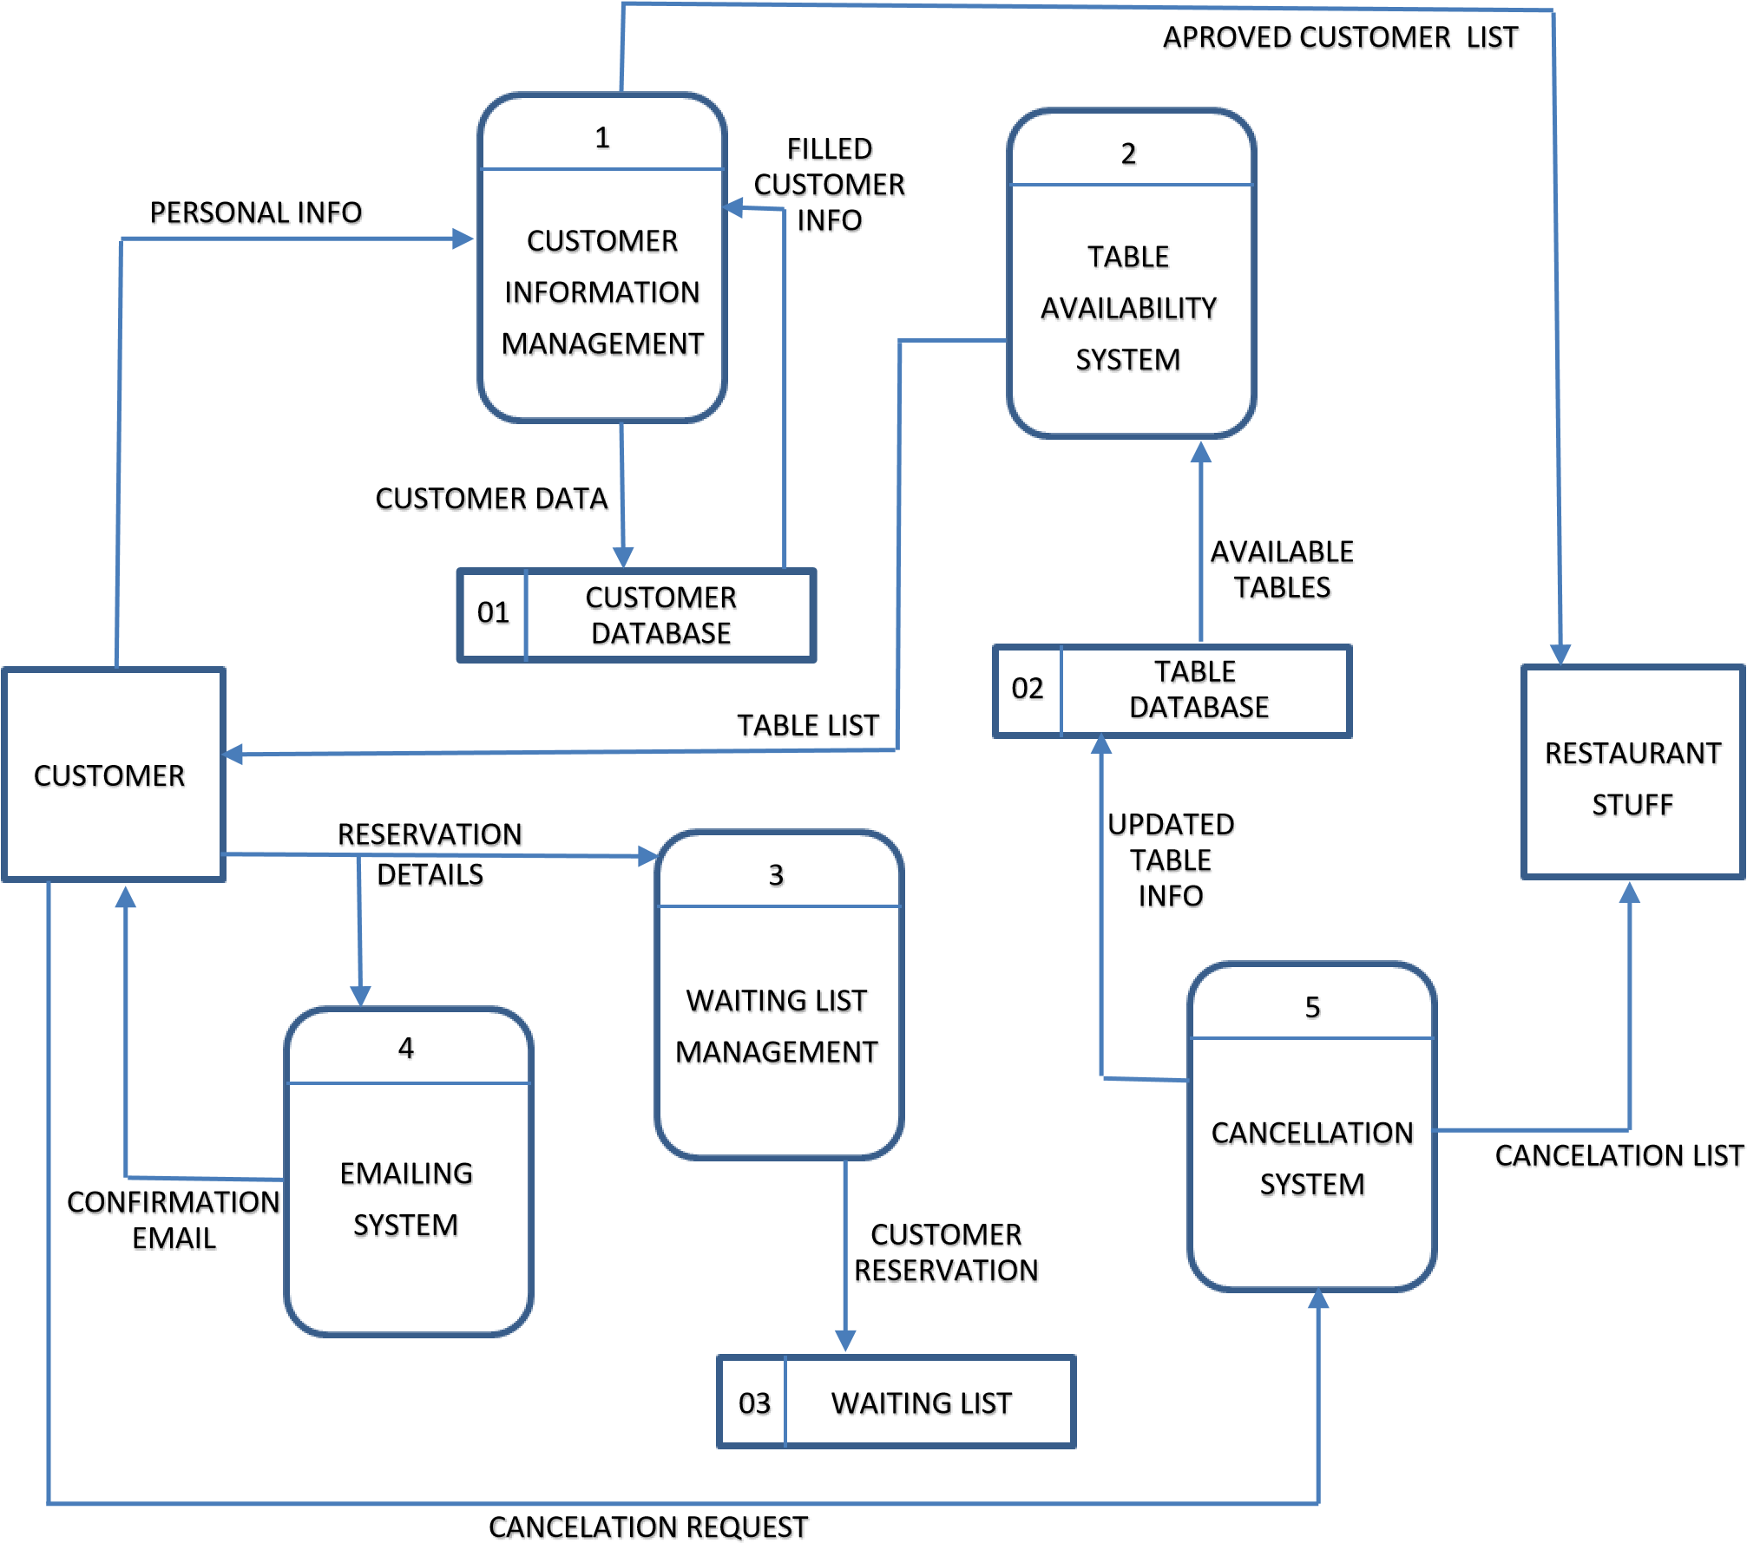

* **Child Diagram (Cancellation Management):**

